INTRODUCTION TO MORAL CENSORSHIP – Cancel culture

A Watch: https://youtu.be/wAIP6fI0NAI?si=Voz9rIPKGE_UCRCl
After the first few minutes, explain in your own words what is meant by:
- Social media shaming (0:44)
- The democratization of justice (0:55)
Finish watching the video, and answer the following questions
- Justine was fired as a consequence of her tweet. What do you think about that? Answer in full English sentences.
- Comment on the following quote: ‘This isn't social justice, it's a cathartic alternative’. (Cathartic = providing psychological relief through the open expression of strong emotions; causing catharsis:
"crying is a cathartic release". In Dutch: louterend, bevrijdend, genezend)

B Make groups of three or four.
These people were cancelled. For each of them, discuss
- why they were cancelled
- what consequences each of them suffered
- how their lives have developed since it happened
- what you think about all of the above (Was justice done?)






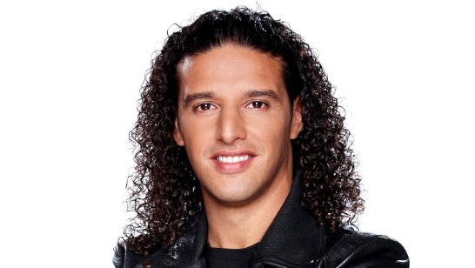

- Matthijs van Nieuwkerk doorbreekt stilte: 'Ik schaamde me helemaal kapot' | RTL Nieuws
- Everything Sean ‘Diddy’ Combs Has Been Dropped From So Far
- Why was J.K. Rowling canceled? The 'Harry Potter' author's controversies explained. (aol.com)
- Elon Musk’s 2025 recap: how the world’s richest person became its most chaotic | Elon Musk | The Guardian
- Justin Timberlake Is Getting Canceled - Newsweek
- Susan Sarandon Forced to Face the Music - Newsweek
- Blake Lively’s Cancellation And The Human Lessons We Can’t Ignore | Thought Catalog
- Ali, Marco en Jeroen gecanceld: 'Reden om vriendschap te verbreken' | RTL Nieuws
- Johan Derksen is niet gecanceld, hij heeft tegenspraak gekregen - Joop - BNNVARA
- Wie bepaalt wie er gecanceld wordt? (en waarom?) - NOS Stories

C Debate
Make groups of at least four people and divide your group into two smaller groups. Assign each group a stance:
- Group 1: censorship is necessary to protect societal morals
- Group 2: censorship limits freedom of expression
Step 1:
In five minutes, prepare arguments
Step 2:
Each group presents their viewpoint and responds to the other side’s arguments. Don’t just list your arguments, but listen and respond. Make sure everyone participates.
Step 3:
After the debate, write down useful arguments for both positions, as well as words or expressions you needed during the debate, and will have to look up.

