MORAL CENSORSHIP / CANCEL CULTURE

Read the poem below and answer the questions.

How to

If you got hiv, say aids. If you a girl,

say you’re pregnant––nobody gonna lower

themselves to listen for the kick. People

passing fast. Splay your legs, cock a knee *spread out, bend*

funny. It’s the littlest shames they’re likely

to comprehend. Don’t say homeless, they know

you is. What they don’t know is what opens

a wallet, what stops em from counting

what they drop. If you’re young say younger.

Old say older. If you’re crippled don’t

flaunt it. Let em think they’re good enough *to show to get admiration*

Christians to notice. Don’t say you pray,

say you sin. It’s about who they believe

they is. You hardly even there.

**Questions:**

1. Who are ‘they’ in the poem?
2. The poem gives instructions on what to do and what not to do in a particular situation. List the dos and don’ts.
3. If you do as instructed, what will ‘they’ think and feel?
4. And what will they do?
5. How could you finish the title: ‘How to….’
6. What is the writer saying?

**Vocabulary**: make a list of the words on the following two pages that are underlined. Give a definition in your own words or translate them into Dutch.

On July 5, 2018, the poem ‘How-To’ by Anders Carlson-Wee was first published in *The Nation,* a magazine for independent journalism which describes itself as principled and progressive.

But the poem came under fire on social media weeks later, from critics calling the poem inappropriate and offensive appropriation.

Trying to find anything poetic in these racist scribbles — nada. Whiteness really is one hell of a drug.

— Pedro da Costa (@pdacosta) July 31, 2018

hey @thenation, you recently published a ridiculously offensive poem ‘how-to’ by anders carlson-wee that flattened & appropriated identities already rendered invisible. aave isn’t a costume. here is my response. do better *AAVE = African American Vernacular English* *Vernacular = volkstaal*

— donte collins 🌻 (@donte_thepoet) July 24, 2018

1. Explain the criticism in your own words.

In response, The Nation poetry editors Stephanie Burt and Carmen Giménez Smith posted an editor's note on the poem, which they said "contains disparaging and ableist language that has given offense and caused harm to members of several communities."

"As poetry editors, we hold ourselves responsible for the ways in which the work we select is received. We made a serious mistake by choosing to publish the poem 'How-To.' We are sorry for the pain we have caused to the many communities affected by this poem," they wrote.

"When we read the poem we took it as a profane, over-the-top attack on the ways in which members of many groups are asked, or required, to perform the work of marginalization," the editors explained. "We can no longer read the poem in that way.

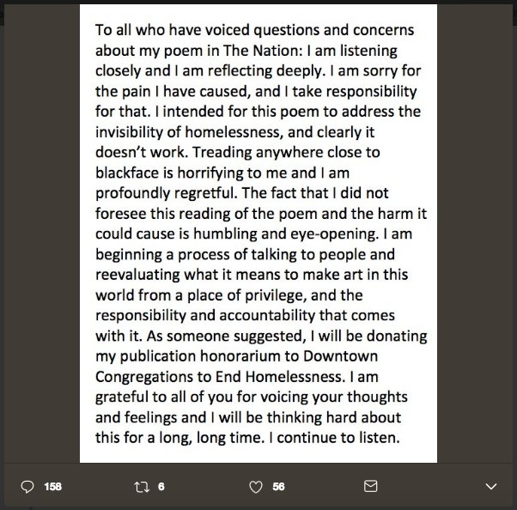The poet, Anders Carlson-Wee, likewise apologized on Twitter (post on the right)

1. What do you think of the editor’s note? Do you consider their apology necessary? Considerate? Or cowardly? Explain your answer.
2. Do you think the poet should apologize for unintentionally offending other people?
3. In general, to what extent are you responsible for hurting other people’s feelings? How careful should we all be not to offend each other?