**INTRODUCTION TO MORAL CENSORSHIP – Cancel culture**

**A Watch:** [**https://youtu.be/wAIP6fI0NAI?si=Voz9rIPKGE_UCRCl**](https://youtu.be/wAIP6fI0NAI?si=Voz9rIPKGE_UCRCl)

**After the first few minutes, explain in your own words what is meant by:**

1. Social media shaming (0:44)
2. The democratization of justice (0:55)

**Finish watching the video, and answer the following questions**

1. Justine was fired as a consequence of her tweet. What do you think about that? Answer in full English sentences.
2. Comment on the following quote: ‘This isn't social justice, it's a cathartic alternative’. (Cathartic = providing psychological relief through the open expression of strong emotions; causing catharsis:

"crying is a cathartic release". In Dutch: louterend, bevrijdend, genezend)

**B Words related to cancel culture**

**Match the following words to their description:**

*Equitable, public shaming, cultural appropriation, to call someone out, mob mentality, to harass someone, backlash, political correctness*

1. to publicly criticize or challenge someone's behaviour or beliefs
2. a strong negative reaction or response, often due to a controversial or unpopular action or statement
3. publicly criticizing or humiliating someone to cause embarrassment or social consequences
4. to persistently intimidate or bother someone with unwanted actions or comments
5. fair and just
6. language and behaviour aimed at avoiding offense or discrimination towards specific social groups
7. behaviour influenced by the collective mindset of a group, often leading to irrational actions or decisions
8. the inappropriate or unacknowledged adoption of an element or elements of one culture or identity by members of another culture or identity

**C These people were cancelled. For each of them, discuss**

* why they were cancelled
* what consequences each of them suffered
* how their lives have developed since it happened
* what you think about all of the above (Was justice done?)

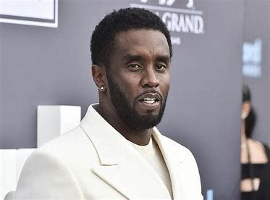

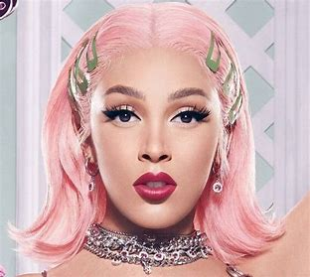 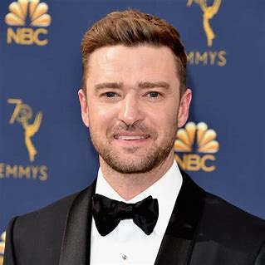 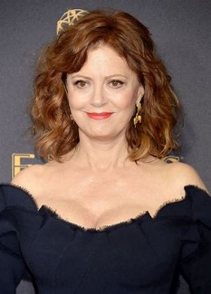

1. [Matthijs van Nieuwkerk doorbreekt stilte: 'Ik schaamde me helemaal kapot' | RTL Nieuws](https://www.rtlnieuws.nl/nieuws/nederland/artikel/5405275/van-nieuwkerk-sprak-na-volkskrant-artikel-met-oud-werknemers)
2. [Everything Sean ‘Diddy’ Combs Has Been Dropped From So Far](https://www.vulture.com/article/sean-diddy-combs-dropped-steps-down-lawsuit.html)
3. [What did Matt Rife say? Domestic violence joke controversy explained as comedian faces cancellation online (msn.com)](https://www.msn.com/en-us/tv/news/what-did-matt-rife-say-domestic-violence-joke-controversy-explained-as-comedian-faces-cancellation-online/ar-AA1kgGdQ)
4. [Why was J.K. Rowling canceled? The 'Harry Potter' author's controversies explained. (aol.com)](https://www.aol.com/lifestyle/why-j-k-rowling-canceled-154219020.html?guccounter=1&guce_referrer=aHR0cHM6Ly93d3cuYmluZy5jb20v&guce_referrer_sig=AQAAADF-TG8OznX-eVoeifCDgEluUUNMexv95o5j_QWbnKj2yzbFkEn3lr3qdvaExO5Ru_9vXZf64B77up4Njp9owvka7DmZ37kZLdR4eFPB3tB_hxWdA7nwtO1Kvu07AKceZiLA63SbmqO-QfxXlhJAYSFPRSjHWyhLLxxOz_QpvutE)
5. [Nas called Doja Cat 'the opposite' of 'unapologetically Black' in his latest single. Here's a timeline of how the Doja Cat was canceled, and then uncanceled, for what some are calling her 'racist past.'](https://www.businessinsider.nl/doja-cat-racist-tinychat-song-lyrics-canceled-twitter-dojacatisoverparty-wearesorrydoja-2020-5?international=true&r=US)
6. [Justin Timberlake Is Getting Canceled - Newsweek](https://www.newsweek.com/justin-timberlake-canceled-britney-spears-janet-jackson-woman-me-1837646)
7. [Susan Sarandon Forced to Face the Music - Newsweek](https://www.newsweek.com/susan-sarandon-dropped-pro-palestinian-1845844)
8. [Ali, Marco en Jeroen gecanceld: 'Reden om vriendschap te verbreken' | RTL Nieuws](https://www.rtlnieuws.nl/editienl/artikel/5282797/ali-marco-jeroen-gecanceld-vriendschappen-verbroken)
9. [Wie bepaalt wie er gecanceld wordt? (en waarom?) - NOS Stories](https://stories.nos.nl/artikel/2426837-wie-bepaalt-wie-er-gecanceld-wordt-en-waarom)

**D Debate**

Make groups of at least four people and divide your group into two smaller groups. Assign each group a stance:

* Group 1: censorship is necessary to protect societal morals
* Group 2: censorship limits freedom of expression

**Step 1:**

In five minutes, prepare arguments

**Step 2:**

Each group presents their viewpoint and responds to the other side’s arguments. Don’t just list your arguments, but listen and respond. Make sure everyone participates.

**Step 3:**

After the debate, write down useful arguments for both positions, as well as words or expressions you needed during the debate, and will have to look up.