Worksheet Novels – Lesson 3:
Cause and Effect/Themes & Quotes
What I know now | Lesson Activities | What I have learned:
What is cause and effect in a story? | 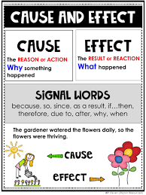  Find Cause and Effect in your novel. There are usually many examples, so be thorough. Therefore, together, go through the storyline and look for 'pivotal' moments. These are moments when something important happens. For example, in Life of Pi, the parents decide to leave their country. Had they not done so, Pi would have never ended up alone on an ocean.  How does this concept apply to your life? Have you ever thought about that? Discuss this as well. | 1.  2.  3.  4.  5.
Do you know what a 'theme' is? | The author likes you to think about issues and recognise themes. Themes are not about what happens (subject) but are abstract words such as love, friendship, grief, regret, etc.  Can you find the themes in your novel? Discuss  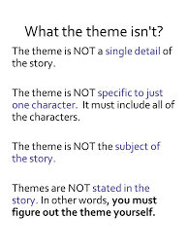  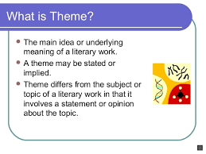 | List your themes and explain your findings.  1.  2.  3.
Quotes often support themes.  Which quotes stood out to you in your novel? | Discuss each other's quotes and see if they fit with the themes you listed earlier. Please give at least three notable quotes and explain their meaning. | 1.  2.  3.

