v6: Essay structure.

# | A very useful visual metaphor | Element |  | Description
0 | 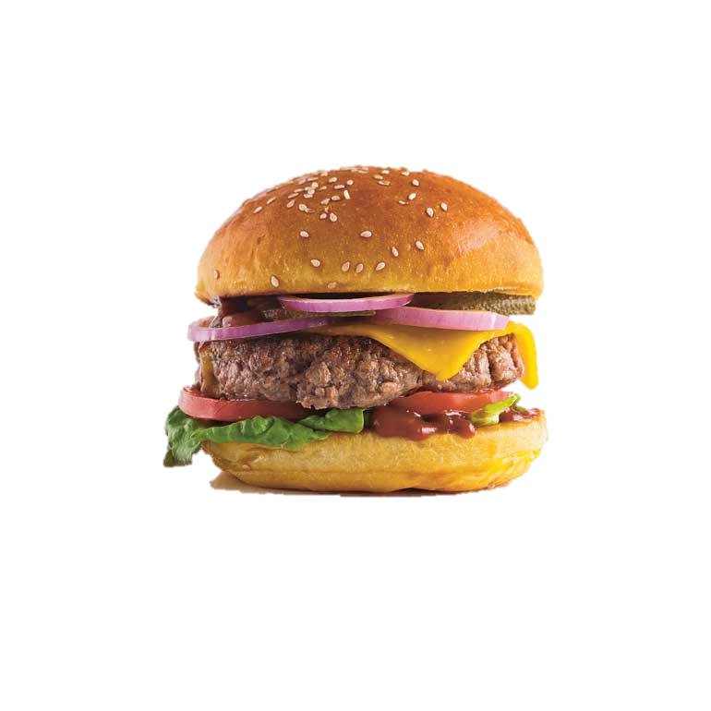 | Title |  | A good title both catches the reader's interest and somewhat predicts the content of the essay.
1 |  | Introduction | Opener | A creative hook that draws the reader’s attention. You could ask a rhetorical question, use current affairs, a compelling statistic, an engaging anecdote, or a provocative thought experiment.
 |  |  | Thesis statement | One sentence with your position and the three clear, specific, and arguable main ideas. The sentence announces and organises the content of the essay.
2 |  | Body paragraph 1 +  body paragraph 2  +  body paragraph 3 | Point (topic sentence) | The point you are making in a paragraph is usually stated in its first sentence and announces and organises the content and function of the paragraph.
3 |  |  | Elaboration | Additional information that clarifies the topic sentence.
 |  |  | Evidence | Provide support through facts, statistics, examples, experts, etc.
4 |  |  | Link | Transitional phrase that refers to the topic sentence and refers to the paragraph’s point in the context of the essay.
5 |  | Conclusion |  | The conclusion generalises and provides the logical continuation of the essay’s ideas. You may provide a warning, recommendation, a call to action, or appropriate quote.
 |  |  | Final sentence | A final sentence leaves a lasting impression, for example through wordplay or by providing closure to a problem posed earlier on.

